Bases & Coordinate Systems

Bases & Coordinate Systems
Letbe a vector space and.
is called a basis (plural bases) forif
- is linearly independent and
- spans.

A basis forcan be used to build a coordinate system for. We can think of bases as coordinate systems for a vector space. For,are known as our basis vectors, or geometrically, the axes of our coordinate system.

Standard Bases
In a vector space, the basisis called the standard basis.
Example:
- is the standard basis for.
- is the standard basis for.

Letrepresent a column vector in the standard basis.
Letrepresent a column vector in basis.
Shown in the figure above, we can arrive atby scaling our basis vectorsby 3, andby 1.
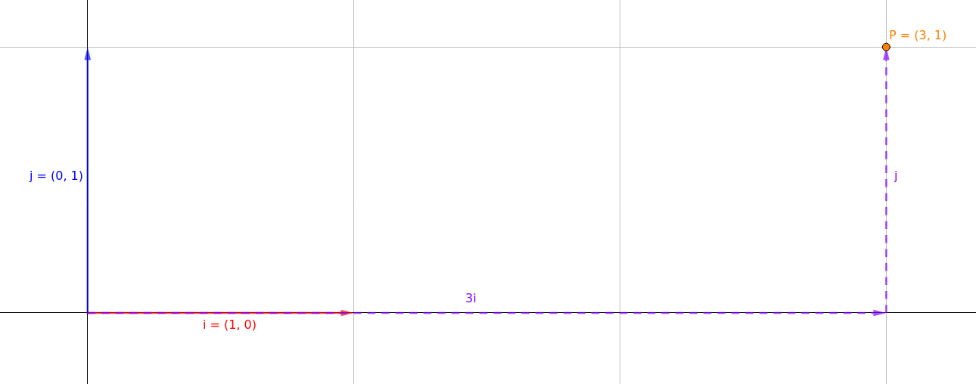Figure 1

Given a coordinate, we can think of it as a scalar of the axes of the coordinate system. For example, considerof the standard basis in. Starting from the origin, we can arrive atby scaling the horizontal axisby 3, and the vertical axisby 1. Writing it as an equation, we get.

Here we see thatandare very important vectors, because our entire coordinate system is governed by assumptions around these vectors. We may think ofas travelling 1 unit towards the right, andas travelling 1 unit upwards.

Non-Standard Bases
Let’s say would like a different set of vectors as our basis vectors, is it possible? Good news, we can! For example, we may decide to useand. This will mean that we have a new coordinate system, one where coordinates are represented as scalars ofand.

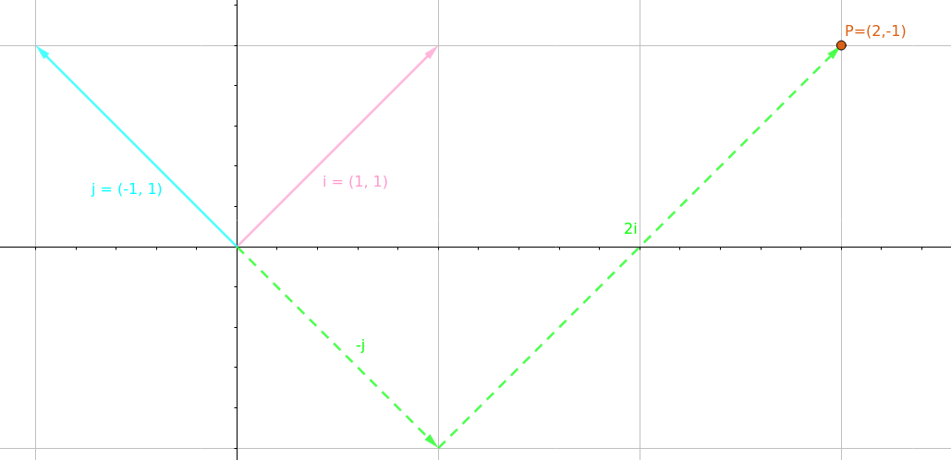Figure 2
Withandas our basis vectors, ’s coordinates has changed. In our new system,’s coordinates is. This means that from the origin, we can arrive at ’s location in space by scaling our basis vectorsby 2, andby -1.

It is important to understandhasn’t actually moved at all. It is still in the same location it always was. The only thing that changed is how it is being represented due to the change in coordinate systems. We can prove this if we overlap the 2 figures.

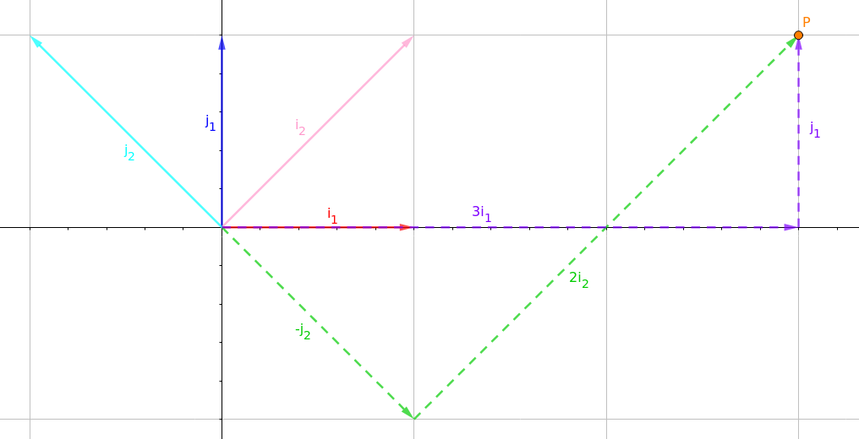Figure 3

Common Cause of Confusion
Looking back at the Figure 2, you might be thinking this: ‘Woah, wait a minute… Scaling our “horizontal axis” by 2 and our “vertical axis” by -1 should give me, but if I write this down as an equation, I get. And as far as I can tell, andare pretty freaking different things!’

Well, yea… One common point of confusion is how we represented the basis vectors versus how we represented.

Letand, the axes of our standard basis beandrespectively.
Letand letandbeandrespectively.

This is where things get a little messy. The vectorsandare represented in standard coordinates even though they are the basis vectors of . This means that when we write,is represented in terms of and. But andthemselves are represented in terms ofand. This is because there is no other way of showing the difference between the standard coordinates and. One coordinate system has to be relative to another, otherwise we would have no way of relating them to each other. Usually, the axes of non-standard bases are relative to the standard basis itself.

Matrix Transformation
Let’s consider the following transformation which can have different meanings, depending on the context.

Transforming A Standard Point

Case 1
Consider the point. In order to move this point, we can apply a transformation matrix onto it.

By applying the transformation matrix, we have movedfromin the standard basis toin the standard basis.

Case 2
Consider another case, where we once again want to move the point. This time, we apply.

By applying the transformation matrix, we have movedfromin the standard basis toin the standard basis.

This is basically the same as the previous example, but I just want to point out that even when given an inverse matrix, we might still only be doing something as trivial as moving a point or vector.
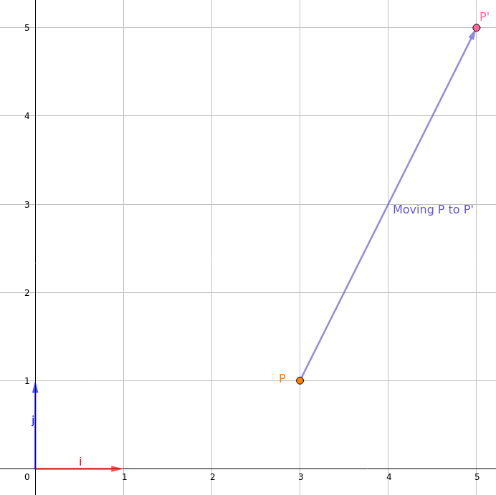Figure 4

Change of Basis

Convert From Basis S To Standard Basis
Letand. What is?
Since we know thatis the sum ofscaled by 3 andscaled by 1, we can derive that in standard space, it is. Alternatively, we can write this using matrices.

Formula for change of basis fromto the standard basis is.

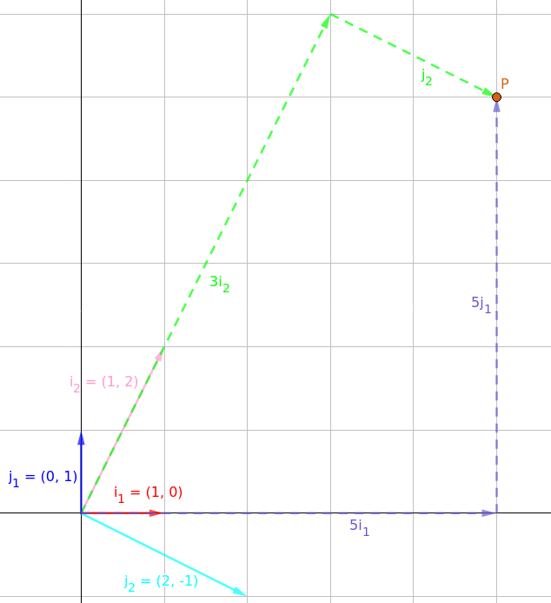Figure 5

Convert From Standard Basis To Basis S
Letand. What is?
Since, and we know that the inverse of a square matrix undoes its transformation, we derive the equation.

Formula for change of basis fromto the standard basis is.

Convert From Basis S To Basis T
Letand. Let. What is?

To find, we can split it into 2 steps.
- Convert fromto.
- Convert fromto.

Thus, we can derive a transition matrixsuch that. We can easily calculateusing Gauss-Jordan Elimination.
→ Gauss-Jordan Elimination →
Thus,.

Formula for transition matrixfor change of basis fromtois.

Summary
In summary, when shown the transformation, there are 4 possibilities:
- (point moves, no change of basis)
- (point moves, no change of basis)
- (point does not move, change of basis)
- (point does not move, change of basis)

